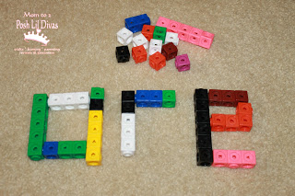
Below is a list of possible ideas to ensure that we keep the teaching and learning of spellings exciting and engaging:
- Online games and activities
- Putting spellings into sentences using fancy pens
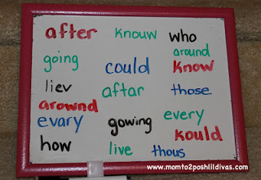
- Sorting words that follow a particular spelling rule into hoops
- A quiz
- Using felt tips and large paper to write sentences together
- Countdown conundrum
- Use of a thesaurus and a dictionary (There is no point children learning to spell words if they have no idea of their meaning)
- How many other ways to say ………………………?
- Making words out of pipe cleaners
- Using magnetic letter tiles to spell out words
- Playing scrabble
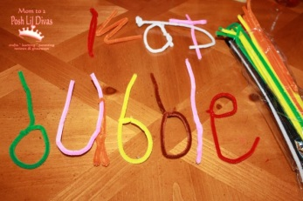
- Using chalks outside on the drive/in the garden
- Can children spot the odd one out?
- Using laptops and Ipads
- What is the missing letter/s?
- Hangman
- Throwing the bean-bag – can you spell……………..?
- Crosswords/word searches
- Writing in a sand tray or wet corn flour.
- Card games – If the adult picks a card with a particular word on, can the child spell this out-loud? If so, they win the card!
Look out for the stay and learn sessions in KS1 for the opportunity to have a go at some of the activities mentioned.

Whole School Spelling

Foundation Stage 2
Foundation 2 children will remain in their own classes for the first term, however when reviewing the KS1 spelling sets and updating groups, these children will then be added and FS teachers will take responsibility for a group (possibly working with the earlier phases).
Look, cover, write, check sheets will be sent home with Foundation children if they can write – we need to be raising the expectation. You may only send 1 or 2 words, but when possible, they need to be having a go.

Key Stage 1
In Key Stage 1, we are going to introduce streaming from the third week in September so by this time, you need to have begun to group your children based on assessment data, phonics screening results and observations. No-one will question your rationale here. Follow your instincts and use your data.
The time table has been changed in order to allow for the 4 teaching sessions and then a slightly longer session on a Friday to allow for a spelling test.
Children are to go to assembly from their phonics/spelling groups and will not go back to class.
Look, Cover, Write, Check sheet is to be sent home as soon as the children can write and spellings are to be sent (even if only 1 to start with) not just words to read.
Although ‘Letters and Sounds’ is being taught well and most children are passing the phonics screening, we must remember to cover all the statutory elements of the spelling curriculum.
Streaming of spelling should enable us to push the competent spellers and plug gaps and support those that are having difficulty.
Handwriting is a perfect opportunity to practise spellings set for homework.
The teacher must be selecting and testing spellings for their entire group; a TA should not be taking children out one at a time.
The phase 3-6 spellings have been typed up on to LCWC sheets ready to send home and there are example word lists in the spelling hand-out to support and ensure coverage.
The number of spellings set each week will depend upon the ability group that you end up teaching during the allocated time but 3 spellings for LAP children and 6 spellings for more HAP children is a guide.
Use your expertise – the teachers that are most confident with phonics needs to close the gaps whereas year 2 teachers would be good at pushing the more able.

Key Stage 2

Children have been placed into spelling groups based upon test scores. Spelling groups will continue every Friday morning 9-9.45am, where the main part of this session is focused around the TEACHING of spelling and not just the testing.
10 spellings to be set each week to be learnt and tested (5 spellings for the three LAP groups).

Common exception words are still to be taught by all staff at every opportunity and a copy is to be stuck in the front of literacy books for children to refer to during independent work. Remember that these are non-negotiable in any written work.

Included is a concise version of the statutory spelling rules and requirements for each year group and I have written some example lists of words to hopefully help when setting spellings to take home, learn and test.

