Foundation Stage
The Nest

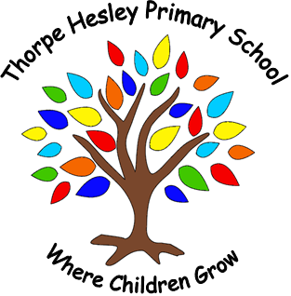

Summer term 2026
We are learning about…
Minibeasts/traditional stories
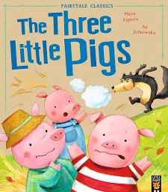
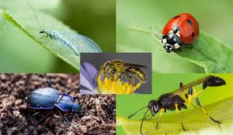

Things to do to help your child:
- Share books regularly with your child.
- Ask your child what they have been learning
- Sing nursery rhymes
- lots of talking with your child when you are out and about listening for environmental sounds.

Useful Websites On our school website there are lots of activities for your child to do. Check it out at
https://thorpehesleyprimary.rotherham.sch.uk/

Other useful websites that may help your child are: http://www.primaryinteractive.co.uk/ http://www.crickweb.co.uk http://www.ictgames.com/ https://whiterosemaths.com/homelearning/early-years/
https://tinytalkers.co.uk/parents-carers/
https://www.bbc.co.uk/tiny-happy-people/2-to-3-year-old-child-development-activities

Remember to send your photos of activities that you do at home to us:
THPTheNest@nclt.ac.uk
This term we will be learning… All about minibeasts and traditional stories.

Area of Learning | Objectives to be covered
Communication and Language | Is the child using pronouns (him,me,she) and using plurals and prepositions (in, on, under)these may not always be used correctly to start with.  Is the child frequently asking questions, such as names of people and objects.
Personal, Social and Emotional | Look for clues about how to respond to something interesting.
Physical | Use large and small motor skills to do things independently, for example manage buttons and zips, and pour drinks.  Show an increasing desire to be independent, such as wanting to feed themselves and dress or undress.
Literacy | Makes comments and shares own ideas.
Maths | Compare sizes, weights etc. using gesture and language- bigger/little/smaller, high/low, ‘tall’, ‘heavy’  Notice patterns and arrange thins into patterns.
Understanding the World | Explore and respond to different natural phenomena in their setting.
Expressive Arts and Design | Explore different materials, using all their senses to investigate them.

Focus for learning
******
Lots of exciting learning will be taking place, including:
• Exploring our outdoors looking for minibeasts.
• learning new stories and creating our own stories through play.
• playing with our friends

*Talking about all different minibeasts
•listening to traditional stories and singing nursery rhymes to support speech and language.
Homework Challenge
Can you please share with us your children’s wow moments this could be anything from saying a new word, joining an out of school activity, drawing a picture. We would love to share these and celebrate all your children’s WOW moments. We have created a new display in a parent area called the ‘proud cloud’ so please take a cloud and write down a proud moment

Thank you from
The Nest Team

